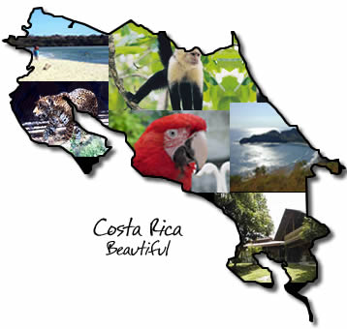
- What is the capital of Costa Rica?

- What nickname do Costa Ricans give themselves?

- There are more than 121 volcanic formations in Costa Rica, how many of them are still active today?

- What is a soda in Costa Rica?

- What is a pulperia?

- For most of Costa Rica, when are the months of the dry season?

- Costa Rica's official language is Spanish, what is the most common second language in Costa Rica?

- Costa Rica is slightly smaller than which Great Lake?

- Costa Rica borders which TWO countries?

- What is the national saying of Costa Rica that describes a sunny, feel good expression used as a greeting, goodbye, or if someone asks how you are doing?

- What did Costa Rica constitutionally abolished in 1949?

- Nearly all Catholic churches face which direction?

- Who is Laura Chinchilla?

